**Adding New User to BBW**

Sample Ticket:- 270250122

1. Currently all the new user requests are being raised in the form of USH BBW Password reset tickets. The following details are needed to be submitted by the user for us to fulfil the request.

* Complete name
* ATTUID
* Access level
* Email ID
* Location

The above details are mandatory for the creation of a new BBW Account.

1. Open the BBW GUI

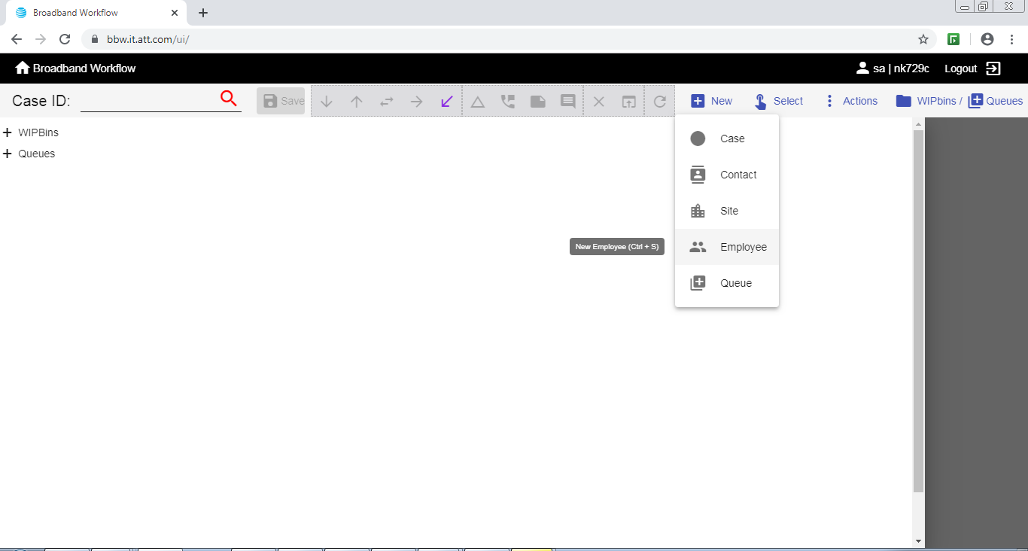

1. Click New and select Employee

The following window will be presented.

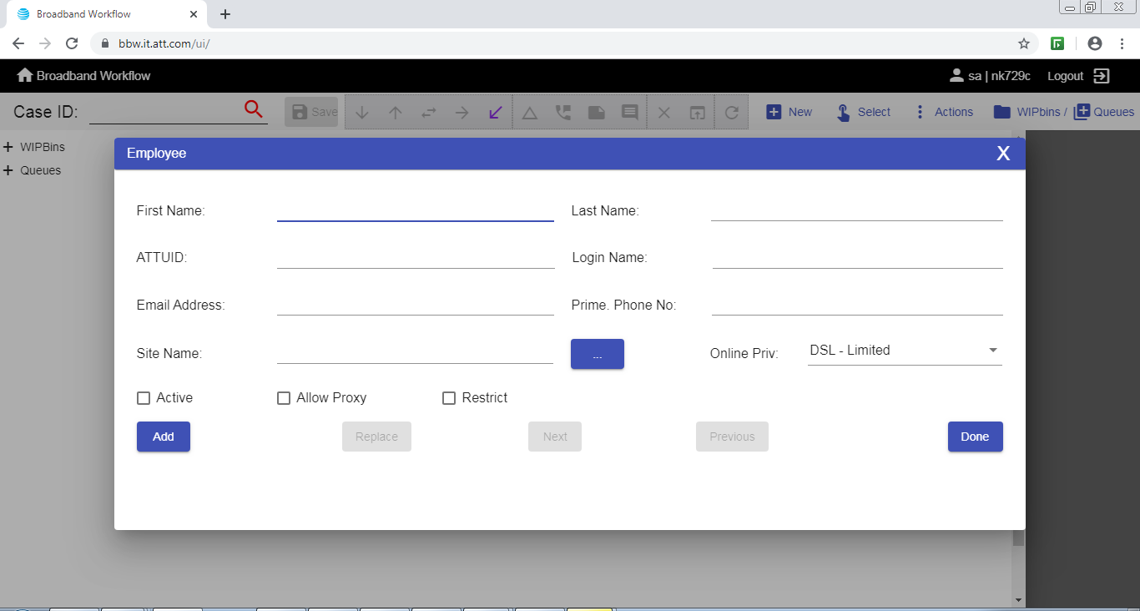

Using the details provided in the USH ticket, populate the respective fields.

Using the sample ticket the following details were fulfilled.

* First Name: Abhra
* Last Name : Ghosh
* ATTUID: ag621h
* Login Name : kol_d_ag621h (location_serviceline_attuid)
* Email Address: [ag621h@att.com](mailto:ag621h@att.com)
* Prime Phone No. : XXXX (as the phone no. was not provided)
* Site Name: Kolkata II (from existing list of sites)
* Online Priv : DSL-General
* Active checkbox – checked
* Allow Proxy : unchecked
* Restrict : checked

Recheck all the fields populated, then click on “**Add**”

Once the ID is created it will be visible as follows,

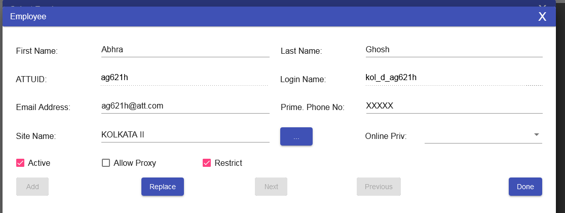

In case some fields have to be changed, edit them and then click “**Replace”.**

**NOTE:-** ATTUID and Login name cannot be changed once edited therefore caution must be exercised while updating them to keep the identifiers unique.

1. Once the ID has been created, update the same in the USH ticket and intimate the user via Q messenger or email. Post verification set the ticket to RTC state.